Health and Safety Policy

  - Health and Safety Policy
  - Organisation for Safety
  - Provision of Competent Health and Safety Advice
  - The Management of Safety
  - Monitoring Safety Performance
  - Faculty or Professional Services Inspections/Annual Safety Return
  - Health and Safety Audits
  - Annual Report: Safety, Environment and Continuity

- Safety Committees
  - Safety, Health and Committee
  - Faculty or Professional Services Safety Committees

- Safety Arrangements
  - Risk Assessment
  - Display Screen Equipment
  - Manual Handling
  - Lone Working
  - Working at Height
  - Slips and Trips
  - Noise at Work
  - Vibration at Work
  - Control of Substances Hazardous to Health
  - Safety Training
  - Smoking
  - Fixed and Portable Appliance Testing
  - Facilities for New and Expectant Mothers
  - Special Waste
  - Stress

- Campus Safety
  - Emergency Procedures
  - Traffic
  - Safety Signs
  - Security
  - Airthrey Loch
  - Residences
  - Young People
  - Dogs
  - Electric Bikes, Scooters and other micro mobility devices
1. HEALTH AND SAFETY POLICY
1.1 Health and Safety Policy Statement
The University of Stirling is committed to providing and maintaining a safe and healthy place of work where staff and students are confident that their health, safety and welfare are of the utmost importance at all times.
The University is also committed to providing a safe and healthy environment for others who may be affected by its activities, such as contractors and visitors to the University.
In satisfying this commitment the University of Stirling will:
• Ensure that University senior and line managers are fully aware of their responsibilities for health and safety and show strong and active leadership on health and safety management: establishing health and safety objectives and ensuring effective risk control and monitoring of health and safety performance,
• Establish effective communication systems and arrangements for health and safety, integrating a sound health and safety management approach with strategic planning processes and decision making,
• Ensure, through a robust system of performance monitoring and audit review, that the University is complying with current health and safety legislation and, where reasonably practicable, aim to achieve higher standards and continual improvement in safety performance,
• Provide appropriate training, information, instruction and supervision to secure the competence of all staff and students,
• Adopt a collaborative approach between Trade Unions, staff Safety Representatives, and University management on health and safety issues,
• Allocate adequate resources to manage health and safety at all levels,
• Ensure that the University has access to competent specialist advice for health and safety.
The University also expects all staff and students to show high standards with regard to health and safety. All staff should be aware that they have statutory duties to take reasonable care for their own safety and the safety of others who may be affected by their actions, and that they must co-operate with the University’s arrangements for Health and Safety.
Professor Gerry McCormac
Principal

1.2 Organisation for Safety
The University, as employer and landowner, bears the primary responsibility for ensuring the health and safety at work of staff, students and all those using its buildings and grounds. University Court is responsible for the oversight of health and safety, influencing the strategic direction and seeking assurance of legal compliance. The University Principal has overall responsibility for the executive management of the University, including the implementation of the safety policy.
The Senior Deputy Principal and the University Secretary have responsibility for the overall provision of a safe and healthy environment in the workplace for staff and others. In general, this will entail ensuring that adequate policies and procedures are in place and that these are being adhered to.
Deans of Faculties and Executive Service Directors have responsibility for safety management within their areas and report to the Senior Deputy Principal or University Secretary respectively.
Deans of Faculties and Executive Service Directors and other responsible officers within Faculties and Professional Services have day to day responsibility for the safe operation of university activities. This entails ensuring that University policies and procedures are followed (including the health and safety management procedures given below), records are kept, risk assessments are made and acted upon, and that supervision and monitoring arrangements are in place to ensure that all of this is being done effectively.
Deans of Faculties and Executive Directors of Service divisions will be able to discharge their responsibilities by implementing, as appropriate to their risk profile, the management system and procedures detailed in the University’s webpages at http://www.stir.ac.uk/safetyandsustainability/safety/a-z/ 2.2 and 3 of this document.
The Head of Safety, Environment and Continuity is responsible for providing competent safety advice and guidance, monitoring health and safety performance against University Standards, establishing the corporate sustainability policy and objectives and directing the University’s business continuity planning and response processes.
The diagram below illustrates the main posts within the University with responsibilities for health and safety. Duties may be delegated at each level but responsibility rests with the named post holder.

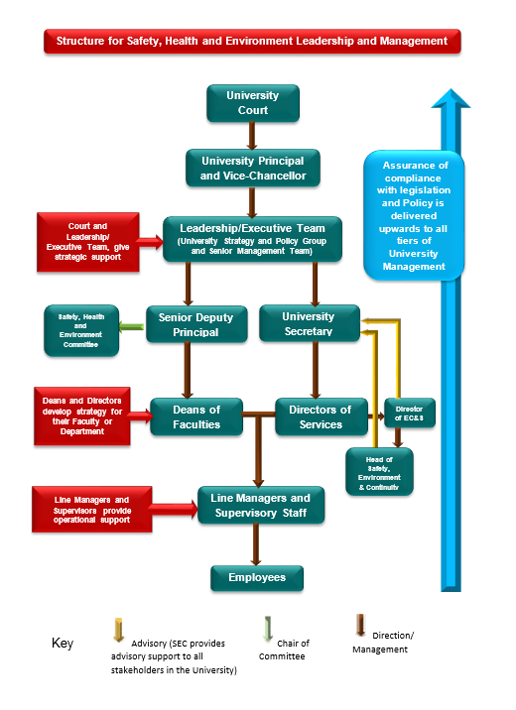

1.3 Provision of Competent Health and Safety Advice
Professional advice is available to all staff regarding health and safety issues. A brief summary of the arrangements is given below.
1.3.1 Head of Safety, Environment and Continuity (SEC)
Contact:-
Alison Morrison: Head of Safety, Environment and Continuity
Tele: 01786 467079
Email: alison.morrison@stir.ac.uk
Web: http://www.stir.ac.uk/safetyandsustainability/contacts/
The Head of Safety, Environment and Sustainability (SEC) is responsible for providing competent advice and guidance, monitoring health and safety performance against University Standards, investigating and reporting on any significant departures from standards, establishing the corporate health, safety and sustainability policies and objectives; and directing the University’s business continuity planning and response processes.
1.3.2 University Fire, Health and Safety Officer (SEC)
Contact:-
Jim Differ: University Fire, Health and Safety Officer
Tele: 01786 466147
Mobile: 07812 122404
Email: jim.differ@stir.ac.uk
Working within SEC, the Fire, Health and Safety Officer provides training and advice on all fire and safety related matters and assists the Head of SEC in the provision of competent safety advice. The FHSO also leads the development of the University Emergency Procedures, ensuring these are maintained.
1.3.3 Health, Safety and Business Continuity Officer
Contact:-
Kyle Phillips: Health, Safety & Business Continuity Officer
Mobile: 07851 525 976
Email: kyle.phillips@stir.ac.uk
Working within SEC, the Health, Safety and Business Continuity Officer provides training and advice on all safety related and business continuity matters and assists the Head of SEC in the provision of competent safety advice. The HSBCO also supports the development of the University Emergency Procedures, ensuring these are maintained.
1.3.4 Environmental Advisor (SEC)
Contact:- Amy Gove-Kaney
Tele: 01786 467338
Email: safetyandenvironment@stir.ac.uk
Working within SEC, the Environmental Advisor works predominantly on environmental and sustainability issues ensuring compliance with legislative and reporting duties.
1.3.5 University Occupational Health Service (OHSAS – contracted service reporting to Human Resources)
Occupational Health Service providers are Innovate Healthcare, they offer advice and provide assistance on occupational health issues and undertake occupational health surveillance where required. The occupational health service does not provide First Aid cover or first aid supplies.
Employees may be referred to the Occupational Health Service via their manager.
1.3.6 University Radiation Protection Advisor (contracted service)
The University Radiation Protection Adviser provides advice to those working with radioactive substances and others who may be affected by this work.
Work with radioactive substances is controlled and monitored at the University by nominated Radiation Protection Officers named below.
Radiation Protection Contact:
Paul Attenborough- Director - RPA Contact
Telephone: 0161 456 9662
Email: paul@northernrpa.co.uk
Web: northernrpa.co.uk

Address:
2 Station View,
Rhino Court,
Stockport,
SK7 5ER

Work with radioactive substances is controlled and monitored at the University by nominated Radiation Protection Officers named below:-
Main RPS - University Contact
- David Copplestone
Tele: t: 01786 467852
Email: david.copplestone@stir.ac.uk

RPA Officers
- Lorna English
Tele: 01786 46 7856
Email: l.c.english@stir.ac.uk

- Peter Smith
Tele: 01786 466544
Email: peter.smith@stir.ac.uk

- Chris Gregson
Tele: 01786 466469
Email: chris.grigson@stir.ac.uk

- Celeste Kellock
Tele: n/a
Email: celeste.kellock@stir.ac.uk

- Ishbel Dale
Tele: 01786 466544
Email: i.h.dale@stir.ac.uk

- Christian Schroeder
Tele: 01786 467754
Email: christian.schroeder@stir.ac.uk

1.3.7 Safety Officers (Appointed by the Dean of Faculty or Executive Service Director)
Safety Officers are appointed by the Dean of Faculty or Executive Service Directors to coordinate safety within the Faculty or Professional Services and act as a point of contact between SEC and the Faculty or Professional Services.
1.3.8 Fire Marshalls (Appointed by the Dean of Faculty or Executive Service Director)Fire Marshalls are appointed by the Dean of Faculty or Executive Service Directors to act as a point of contact between the University Fire, Health and Safety Officer and Faculty or Professional Services and to advise locally on fire related issues.
1.3.9 Workstation Assessors (Appointed by the Dean of Faculty or Executive Service Director)
Department Workstation Assessors are appointed by the Dean of Faculty or Executive Service Directors to provide support for workstation issues and to check that the University procedures for the health and safety of computer users are followed.
SEC provides information, training and support for appointed Safety Officers, Fire Marshalls and Workstation Assessors to enable them to carry out these roles in a competent way.
1.4 The Management of Health and Safety
The main elements of health and safety management are:
- Having a clear Health and Safety Policy,
- Having clear responsibilities and accountabilities,
- Having a communication and training infrastructure that supports the policy,
- Providing a systematic approach that embeds Health and Safety management into the general management processes,
- Providing sufficient resources for the effective implementation of the plans,
- Having a coherent set of health and safety performance measures,
- A review of the effectiveness of the system.
The University has an established Safety Management system called Health and Safety Management Profile - HASMAP (based on the Management of Health and Safety at Work Regulations 1999, the Health and Safety Guide, HSG 65 (revised), and the UCEA University Health and Safety Management - code of best practice. This is designed to be used by Faculties and Professional Services to assist in the identification and discharge of health and safety responsibilities. The system is designed to progressively develop health and safety management, information and recording in Faculties and Professional Services.
Regular review by the Faculty or Professional Services of the implementation of the safety management system is essential to keep the information up to date and to ensure that the arrangements for safe working are implemented and are effective.
Safety, Environment and Continuity Personnel (SEC) undertake audits of Faculties or Professional Services using HASMAP.
Detailed guidance on HASMAP can be found by visiting: - Health and Safety Management Profile (HASMAP) 2022 - USHA

1.5 Monitoring Safety Performance
The University has a system for the monitoring of health and safety performance across the University. The following summarises the lines of communication for monitoring, which is generally based on a system of inspections and audits.

University Court

Health and Safety Committee

Head of Safety, Environment and Continuity

Deans of Faculties and Executive Directors of Services
(Annual Safety Returns; Faculty or Service Area inspections and audits)

Department Safety Officers Union/Staff Safety Representatives
(Faculty or Service Area Safety Inspections)

1.6 Faculty or Professional Services Inspections/Annual Safety Return
A system of self-inspection by Faculties and Professional Services is in place. Inspections should be carried out on a regular basis, dependent on the risk within the Faculty or Professional Services.
Each Faculty or Professional Services must complete an Annual Safety Return that reports on key safety criteria. The completed Return is forwarded to SEC before 31 August each year. The Annual Safety Returns are collated and included in the Annual Safety and Continuity Report produced by the Head of SEC.
1.7 Health and Safety Audits
SEC undertakes a programme of safety management audits of Faculties or Professional Services throughout the year. Audit reports, with recommendations, are discussed with the Dean of Faculty or Professional Services so that a coordinated response with details of proposed time scales for the action can be made.
1.8 Annual Safety, Environment and Continuity Report
The Head of SEC prepares an annual report summarising the university’s health and safety performance over the academic year. The report is based on the Annual Safety Returns, audit reports, accident statistics and other contact between the Head of SEC and the Faculties or Professional Services. The annual report is discussed at the Health and Safety Committee.

2. SAFETY COMMITTEES
2.1 Health and Safety Committee
The University Health and Safety Committee convenes twice each year and has representatives from all areas of the University, including the Trade Unions. The Health and Safety Committee reports to the Joint Policy Planning and Resources Committee.
The Committee is chaired by the Senior Deputy Principal and the Safety, Environment and Continuity Administrator acts as the Secretary.
The remit and membership of the Health and Safety Committee may be found at:
HSC - Remit & Membership
2.2 Faculty or Professional Services Safety Committees
Each Faculty or Professional Services is required to have a Health and Safety Committee that meets one or more times each year depending on the risk profile arising out of the activities of the Faculty or Professional Service. All members of the Faculty or Professional Services staff should be represented on the committee and be informed as to whom their representative is and when the committee is meeting. Minutes of meetings should be made available to all members of staff within the Faculty or Professional Services.

3. SAFETY ARRANGEMENTS
3.1 Risk Assessment
The general duties imposed by the ‘Health and safety at work, etc. Act 1974’ and the ‘Management of Health and Safety at Work Regulations 1999’ require the University to perform risk assessments by:
- using competent personnel to identify workplace hazards,
- making a suitable and sufficient evaluation of the health and safety risks posed by their work activities and anyone affected by them, so far as is reasonably practicable,
- determining and implementing any remedial actions required to remove or reduce the identified risks. This includes management programmes to ensure the controls are maintained, and
- recording the significant findings of the risk assessment.
Risk assessments are also an important piece of ‘evidence’ sought by regulators in the event of an accident investigation or a prosecution being brought.
Assessing the risks posed by workplace hazards is the key practical task of health and safety management. The aim is to ensure that hazards are comprehensively identified, evaluated and managed. It is a central feature of health and safety legislation covering hazardous substances, display screen equipment, manual handling, and fire safety (among many other more specialised topics). The methodology is similar in each case.
Risk assessment is a means of ensuring that the most significant workplace risks are managed to implement sufficient and cost-effective controls. These might include elimination of the hazard, engineering controls, safe systems of work, permit to work procedures, safety training, or use of personal protective equipment. The process of risk assessment and review lends itself to a continuous cycle of work improvement.

Staff with Line Management Responsibility (including Principal Investigators in research units):
Are responsible for assessing the risks under their control. The assessment will:
- identify any hazards,
- identify who might be harmed by the hazards,
- assess the level of risk,
- evaluate the effectiveness of any existing control measures,
- identify any further control measures considered necessary to make the risk acceptable,
- record the significant findings of the risk assessment,
- bring the significant findings to the attention of all staff (and others) affected by them,
- ensure staff are trained on procedures or working practices introduced as a consequence of the risk assessment, and
- review and update the risk assessment regularly (annually or when working procedures alter significantly).
Heads of Faculties and Service Directors are responsible for coordinating the risk assessment process and ensuring that adequate resources are provided to carry out the assessments effectively and introduce any necessary control measures.
SEC provides information, regular training events and support for staff undertaking risk assessments and has produced a range of basic risk assessment templates that can be used to complete risk assessments for a range of activities. These can be found on our web
page:- http://www.stir.ac.uk/safetyandsustainability/safety/a-z/ and include the following Risk Assessment forms:-

- Risk Assessment - Form Current 2023.docx (sharepoint.com) and Risk Assessment Procedures Nov 2023.docx (sharepoint.com)
- COSHH Risk Assessment Sept 23

3.2 Display Screen Equipment
The University has arrangements in place to ensure that it meets the requirements under the Health and Safety (Display Screen Equipment) Regulations 2002.
All staff who use a computer as part of their work are considered ‘users’ of display screen equipment. Staff who fall into this category must complete the Hybrid Working (DSE) online Induction course, there is also a self-assessment which will highlight any workstation issues.
This can be found on the Health & Safety Training platform, WorkRite: https://portal.stir.ac.uk/security/sso/workrite.jsp?q=WR
The Dean of Faculty or Executive Service Director is required to nominate one or more members of staff to become Workstation Assessors. Training is provided by SEC to ensure that the assessors are competent or contact SEC who can provide a basic workstation assessment and advice on a suitable workstation set up, any medical issues, need to be referred to the Line Manager who will refer to Innovate Health Care, our Occupational Health providers.

The Dean of Faculty or Service Director is responsible for ensuring that all users of display screen equipment have completed the induction course and their workstation assessment. The DSE Induction course and Workstation assessment should be repeated periodically (every three years) or when their circumstances change e.g. an office refurbishment, new equipment etc.
Staff who use display screen equipment are responsible for following the arrangements put in place, any advice given to them and for reporting any hazards or problems with their computer equipment.
The University has made arrangements to offer eyesight screening for all users of display screen equipment. This is available by obtaining a voucher (available from SEC) under the University’s corporate eye care system. This enables the member of staff to have a full eye and eyesight examination and obtain a basic pair of glasses for use with Display Screen Equipment at the approved optician. The cost of the voucher is met by the University.
3.3 Manual Handling
The University has arrangements in place to ensure that it meets the requirements of the Manual Handling Operations Regulations 1992.
Managers are required to carry out risk assessment of the work activities which they supervise and to identify which of these involve significant risk of injury through carrying out manual handling activities e.g. lifting, carrying, pushing or pulling.
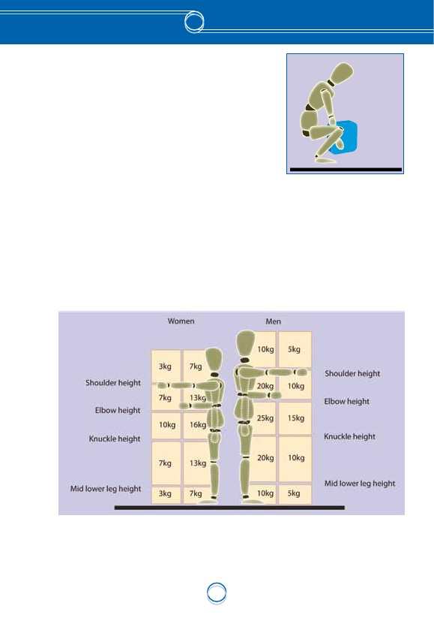
Managers are required to implement control measures to reduce the risk of injury from Manual Handling activities which may include avoiding the task, providing mechanical assistance, redesigning the work activity, training, changing the load size or shape. As an easy guide, working within the weight guidelines below will help to reduce the risk from manual handling activities. Staff involved with Manual Handling activities are required to follow the arrangements put in place to reduce the risk from these activities and to report any hazards or injuries resulting from Manual Handling activities. Such staff include office- based staff who handle boxes of copier paper, heavy files, etc.

3.4 Lone Working
Lone working is generally accepted to mean working in an area or in circumstances where there are no other workers present. Therefore, in the event of an emergency there would be no one to give assistance or summon help. There is no time limit attached to working alone - it may be for the whole work period, or for a much shorter period of time. Not all activities involving lone working present a high risk.
Activities which may present a high risk when working alone include:
- access to and from the workplace using ladders,
- entry into confined spaces,
- handling biological substances,
- handling flammable substances, for example organic solvents,
- handling valuables,
- lone occupation of rooms fitted with automatic fire protection systems where the noise of the system discharging may cause hearing damage,
- working alone and directly with members of the public (including research/survey work),
- work with high pressure systems ,e.g steam boilers and pipelines,
- work with toxic substances, for example cyanides.
Activities which may present lower risks include:
- cleaning duties,
- office work out of hours,
- static security work (e.g monitoring CCTV).
Regardless of the reasons for working alone, steps must be taken to carry out a risk assessment of the lone working activity with control measures put in place to reduce the risks to as low as reasonably practicable. All lone workers should be aware of the risk reduction procedures and should know what to do in the case of an emergency.
There are no specific prohibitions regarding working alone, but there are several items of legislation which require more than one worker to be involved in a specific activity:
- Control of Substances Hazardous to Health 2002. Certain fumigation work and other work with substances hazardous to health,
- Electricity at work regulations 1989. Work at, or near, a live electrical conductor,
- Confined Spaces Regulations 1997. Entry into a confined space, for example, sewers or tanks.
When planning to introduce lone working, employees must be consulted (through the department safety committee).

3.5 Working at Height
The Work at Height Regulations came into effect on 6 April 2005. The Regulations apply to all work at height where there is a risk of a fall liable to cause personal injury.
The Regulations place duties on the University to ensure:
- all work at height is properly planned and organised,
- those involved in work at height are competent,
- the risks from work at height are assessed and appropriate work equipment is selected and used,
- the risks from fragile surfaces are properly controlled,
- equipment for work at height is properly inspected and maintained.
The Regulations include Schedules giving requirements for existing places of work and means of access for work at height, collective fall prevention (e.g. guardrails and working platforms), collective fall arrest e.g. nets, airbags, etc.), personal fall protection (e.g. work restraints, fall arrest and rope access) and ladders.
There is a simple hierarchy for managing and selecting equipment for work at height. University staff must:
- avoid work at height where possible and use work equipment or other measures to prevent falls where you cannot avoid working at height.
- where the risk of a fall cannot be eliminated, there should be use of work equipment or other measures to minimise the distance and consequences of a fall should one occur.
3.6 Slips, Trips and Falls
Slips, trips and falls are the most common cause of injury at the University, accounting for approximately one third of all reported injury accidents. The causes of these may include obstructions, poor floors/finishes, poor lighting, slippery or icy surfaces, etc. They may be avoided through taking care, concentrating and watching where you are walking, good housekeeping and maintenance. Where you see a situation that could cause a slip, trip or fall, remedy it if you can or report it immediately to your supervisor or by contacting 2444.

3.7 Noise at Work
The Control of Noise at Work Regulations 2005 came into force on 6 July 2006 and replaced the Control of Noise at Work Regulations 1989.
Exposure action values and exposure limit values have been set by the Regulations. The exposure action values are the levels of exposure to noise at which certain actions are required to be taken. The exposure limit values are the levels of noise above which an employee may not be exposed.
The lower exposure action values are:
- a daily or weekly personal noise exposure of 80 db(a),
- a peak sound pressure of 135 dB(C).
The upper exposure action values are:
- a daily or weekly personal noise exposure of 85 db(a),
- a peak sound pressure of 137 dB(C).
The exposure limit values are:
- a daily or weekly personal noise exposure of 87 db(a),
- a peak sound pressure of 140 dB(C).
A weekly personal noise exposure value may be used where exposure to noise varies markedly from day to day.
The Control of Noise at Work Regulations 2005 affects staff who work in noisy environments or with noisy equipment. The duties require that noise assessments are undertaken (specialist equipment is required – refer to SEC) and, where exposure to noise is more than the first action level of 80 dB(A)w to:
- reduce exposure,
- provide information and training for employees, and
- issue personal hearing protection.
As a guide, normal conversation measures around 50 – 60 dB(A), a loud radio 65 – 75 dB(A), a chain saw 115 – 120 B(A). Note that a 3 dB(A) change in sound pressure level corresponds to an approximate halving or doubling in loudness.

3.8 Vibration at Work
The Regulations define an exposure action value of 2.5m/s² for hand arm vibration and an exposure limit value of 5.0m/s². The exposure action value defines an exposure level at which point an employer must aim to reduce the exposure to as low a level as is reasonably practicable. If an employee’s exposure is above the exposure limit value an employer must reduce the exposure to below the limit value.
Vibration at Work Regulations came into effect on 6 July 2005
Hand arm vibration syndrome (HAVS) is a disorder that affects the blood vessels, nerves, muscles and joints of the hand, wrist and arm and is caused by the use of tools that have high vibration levels.
Some effects are:
- impaired blood circulation and blanching of fingers and parts of the hands (known as vibration white finger),
- numbness and tingling of the fingers and hands, reduced ability to grip objects and reduced sensitivity both of touch and to temperature, and
- pain and stiffness in the hands and joints of the wrists, elbows and shoulders.
The signs to look out for are:
- in the cold and wet, fingers going white, then blue, then red and becoming painful,
- the possibility of difficulty feeling things or picking up small objects such as screws or nails,
- pain, tingling and numbness in the fingers, hands, wrists and arms, and
- possible loss of strength in hands.
The magnitude of vibration is measured in terms of the acceleration of a tool (rapidly moving backwards and forwards, up and down), in metres per second squared - m/s². The readings are then converted to correspond to an 8-hour working day.
This legislation is relevant where motorised hand tools and machines are used on a regular basis, e.g. by Gardens and Grounds, Trades and Cleaning staff. In these areas, risk assessments should be reviewed and levels of vibration for the equipment used should be taken (specialist equipment is required – refer to SEC to organise this). This may affect the length of time and frequency of which some equipment can be used by any one individual and may also require annual health surveillance checks. Consideration should also be given to vibration when purchasing new equipment.

3.9 Control of Substances Hazardous to Health
The Control of Substances Hazardous to Health Regulations are intended to protect people from ill health caused by exposure to hazardous substances at work.
The Regulations require employers to:
- assess the risks to health and safety,
- decide what precautions are needed to prevent ill health,
- prevent or control exposure,
- make sure that the control measures are used and maintained,
- monitor exposure and carry out health surveillance if appropriate, and
- ensure that all employees are properly informed, trained and supervised.
Hazardous Substances are defined as:
- chemicals - classified under ‘the European ‘CLP Regulations’ are identified by black and white, red bordered, hazard warning symbols on the container e.g., acute toxicity, serious health hazard, corrosive etc. Be careful with containers that are not properly marked or where labels are damaged! Be aware also that containers may be marked with older pictograms (orange and black),
- any substance that has been assigned a workplace exposure limit, a WEL, (previously an occupational exposure standard - OES - or maximum exposure limit - MEL),
- dusts in concentrations in air greater than 10 mg/m³ inhaled dust, or 4 mg/m³ of respirable dust,
- biological agents such as bacteria, viruses, fungi and parasites,
- asphyxiants such as carbon dioxide and nitrogen, or
- carcinogens such as benzene or formaldehyde.
Routes of entry into the body:
- inhalation - breathing in vapours, gases, dusts and fumes,
- ingestion - eating or drinking hazardous substances or foods contaminated by hazardous substances,
- absorption on or through the skin - contact with the skin can cause harm to the skin itself or substances can be absorbed into the body through the skin causing harm to internal organs.
- eyes - contact with the eyes by fumes, vapours, liquids and dusts, or
- injection - liquids, solids or gases through the skin either by puncture wounds or through cuts.

An example of COSHH risk assessment can be found here: COSHH Risk Assessment Form

Some do’s and don’ts when carrying out a COSHH risk assessment.
- do identify all hazardous substances used.
- do ensure that the COSHH data sheets are received from the suppliers.
- do carry out risk assessment for each activity that uses hazardous substances.
- do assess the hazards arising from unplanned interactions between substances or activities.
- do implement control precautions and check that these are being followed.
- do contact Occupational Health if anyone starts to suffer ill health as a result of using a hazardous substance.
- do make sure that all people doing the activity are familiar with the risk assessments. Include staff carrying out tasks they don’t normally do i.e. when covering for absence.
- do review risk assessments annually or when circumstances change.
- don’t simply rely on COSHH data sheets provided by suppliers. You should use this information to produce specific risk assessments for activities using harmful substances.
- don’t expect people to know that a substance is hazardous - it may not be obvious.
- don’t ignore health concerns from staff e.g. rashes, allergies, asthma. Some people may be more affected than others.
- don’t rely on personal protective equipment as the only means of control. It is the last line of defence.
3.10 Safety Training
All staff must complete their mandatory on-line Health & Safety training, immediately commencing their employment (or within 1 month of employment). These courses should be repeated every 3 years.
The Training Needs Analysis (TNA) should be undertaken, and any further training identified should be completed as required.
Staff can access all our Health and Safety training courses here.

3.11 Smoking
On 26th March 2006 the Smoking, Health and Social Care (Scotland) Act and the Prohibition of Smoking in Certain Premises (Scotland) Regulations 2006 came into force. From this date, smoking is prohibited in all wholly or substantially enclosed public places in Scotland.
A Smoke Free policy has been developed for the University. This policy came into effect on 26th March 2006 and prohibits smoking, including vaping, throughout all University buildings, around entrances to buildings, within internal courtyards or in any University vehicle.
The full policy can be viewed at: Smoke Free Policy 201805 current.docx (sharepoint.com)
Information on assistance to give up smoking is available from Student Support Services or from Innovate Healthcare.
3.12 Fixed & Portable Appliance Testing
Fixed electrical equipment testing:
A programme for the testing of fixed electrical systems is organised by E&CS Property Management. Some Faculties and Professional Services have equipment or machinery that is hard wired into the mains supply. Testing of fixed systems will only be made up to the point of supply unless specific arrangements have been made with E&CS Property Management.
Portable Appliance Testing
A Portable Appliance is defined as equipment that is powered by being plugged into the mains electrical supply.
Deans of Faculties and Executive Service Directors are required to organise the periodic inspecting and testing of all Portable Electrical Equipment under their control in liaison with Estates and Campus Services, Property Management section.
Property Management have made arrangements with an electrical contractor to carry out this work and maintain a register of all equipment tested. To arrange testing, contact should be made with the Property Management (Tel 7096) who will ask for a full list of equipment to be tested and a budget code to which the cost of testing should be charged. An estimate for the cost of testing can be provided if required. Property Management will liaise with the Faculty or Professional Services contact, to arrange a suitable time for the testing to be carried out. On completion of the testing the Faculty or Professional Services will be provided with a report of the testing and any remedial action that is required.

Inspection
Around 95% of faults or damage on portable electric equipment can be found by carrying out a visual inspection of the item and associated plug and lead. A suitable formal inspection will include the following elements:
Inspect the appliance to ensure that:
- the equipment is not physically damaged,
- all covers etc. are in place,
- air is allowed to circulate freely around the appliance, and
- air vents are not blocked.

Inspect appliance lead to ensure that:

- the lead is intact and without cracks or fraying,
- there are no joins other than those made by the manufacturer,
- there are no kinks in the lead,
- the lead does not have to be stretched taut to reach the socket outlet, and
- all push in connections are firmly in place.

Inspect the plug to ensure that:
- there are no visible cracks or deterioration of the casing,
- there are no visible scorch marks,
- pins are not loose or bent,
- the cable clamp firmly grips the outer insulation of the cable, and
- the fuse is the correct rating for the appliance.
Testing
A suitably trained person should carry out the following tests.
- earth Bond Test, and
- insulation Test.
Frequency
The following table gives guidance on the frequency of formal inspections and tests. If electrical equipment is to be used in adverse conditions then the frequency of tests / inspections should be increased.

Guide To the Frequency of Inspection and Testing of Portable Electrical Equipment.
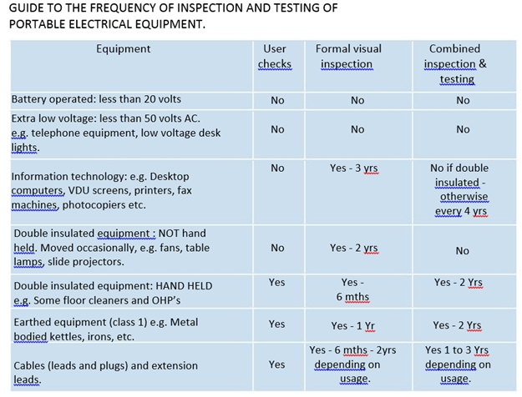
3.13 Facilities for New and Expectant Mothers
The University has arrangements in place for when a member of staff becomes pregnant and for when she returns to work.
As soon as the member of staff becomes aware she is pregnant she should advise Human Resources. Human Resources will arrange with the Dean of Faculty or Executive Service Director to carry out a short risk assessment to identify if there are any additional work risks arising from the pregnancy and to put control precautions in place should they be required.
Prior to carrying out the risk assessment, the Dean of Faculty or Executive Service Director should read the HSE booklet ‘New and Expectant Mothers at Work’ (available from SEC).
The New and Expectant mother should read the HSE leaflet ‘New and Expectant Mothers ‘who work’ (available from SEC).
In addition to this, there is a ‘New and Expectant Mothers’ room located in Cottrell Building, Room 2B72.
Access to the Nursing Mothers Room:
Access to this room is controlled and users will be required to obtain and return the key from the Security desk which is based at 2A2. The room is kept locked until needed.
Facilities:
The ‘New and Expectant Mothers’ room (2B72) has a bed, chair, mini-fridge for storing breast milk, (which should be labelled) as well as a wash hand basin, soap and paper towels.
Baby Changing Facilities
Baby Changing facilities are located in Accessible Toilets across the Academic Campus Buildings. These generally have a pull-down baby changing pod, hot water soap and towels. The doors of these toilets, in addition to being labelled with the Accessible Toilet sign are also labelled with a “baby changing facility” symbol (examples of both are shown below).
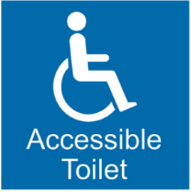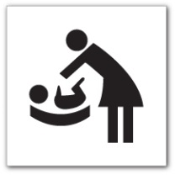
3.14 Special Waste
The Special Waste Amendment (Scotland) Regulations 2004 amend the Special Waste (Scotland) Regulations 1997 and came into force on 1 July 2004.
Special Waste is so called because it has hazardous properties that may render it harmful to human health or the environment.
Examples of waste classed as Special Waste include:
- asbestos,
- lead-acid batteries,
- electrical equipment containing hazardous components such as cathode ray tubes,
- oily sludges,
- solvents,
- fluorescent light tubes,
- chemical wastes, and
- pesticides.
Special waste cannot be placed into normal domestic waste bins. The University has arrangements in place, and makes use of specialist contractors, to deal with Special Waste. If you are uncertain about the waste you have, please contact the Cleaning and Waste Manager for advice on how to dispose of the waste.

3.15 Stress
The University of Stirling’s Policy on Stress has been developed by Human Resources Services working in association with Safety, Environment and Continuity in consultation with management and staff representatives. The policy applies to all employees, workers and students on work placement. This policy has the same status and force as all other University policies and can be found at
https://www.stir.ac.uk/about/professional-services/estates-and-campus-services/safety-environment-security-and-continuity/safety/a-z/stress-policy/
4. CAMPUS SAFETY
4.1 Emergency Procedures
Procedures for contacting Emergency Services (Police, Fire Service, Ambulance or Paramedics)
In the event of an emergency which requires the attendance of the Police, Fire Service, Ambulance or Paramedics call 999 from any phone. Then contact Security immediately after by calling ext. 7999 (internally) or 01786 467999 from a mobile phone which will allow them to guide the emergency vehicle to the exact location.
The University’s Security team have been trained in co-ordinating the response in emergency situations and are able to ensure that emergency vehicles arriving on campus are directed, without delay, to the appropriate location.

On dialling the emergency numbers listed above you will typically be asked to provide a number of key details. These will include:
- Your name and contact telephone number
- Nature of emergency
- Exact location of the emergency
- Details of number of persons involved/number of casualties
- Any other relevant information
4.2 Traffic
The University enforces its own traffic regulations. These regulations govern the use of the roads and the safe parking of vehicles within the Campus. In addition, all roads within the University come under the provisions of the Road Traffic Act and consequently the Police can deal with traffic offences on campus under this legislation.
4.3 Safety Signs
Safety signs are displayed throughout the University and are used when specific risks cannot be avoided, engineered out or reduced significantly by a safe system of work. All persons must observe these signs and the meaning they convey.
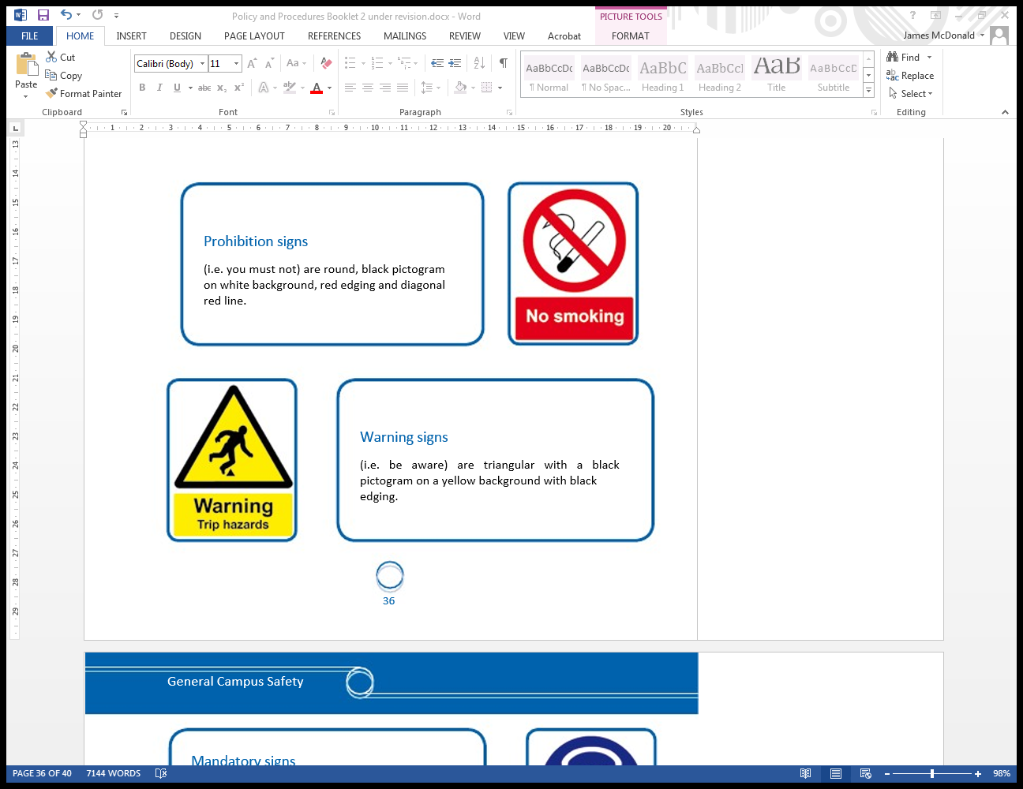
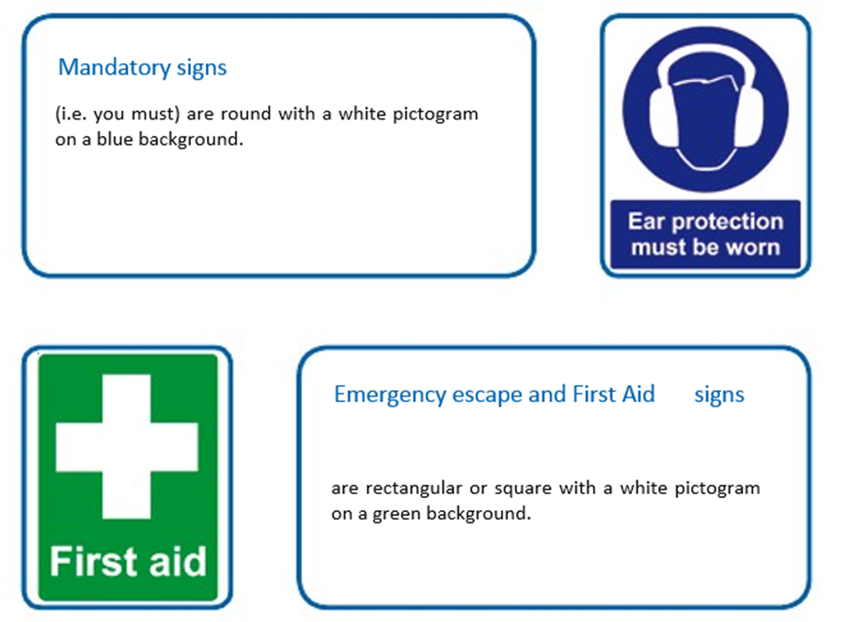

4.4 Security
The University’s Security team provide security cover for the main Stirling campus 24 hours per day, 365 days of the year and may be contacted at 01786 46 7003 or in an emergency 01786 46 7999.
The team can also be contacted immediately through the SafeZone app which can be downloaded and accessed through the SafeZone tile on the Stirling Uni App.
For further information please visit: SafeZone
The Security team carry out regular patrols of the site, the grounds, and all buildings except the interior of the residences. They report on any faults and deficiencies observed and attend and assist at all emergencies.
They also carry out security duties to prevent damage to property, protection of personnel, and deal with any emergency that may arise on campus. If the services of the Police are required at any incident on campus, they can be called through the Security Office, using the emergency number 01786 46 7999, or directly by a member of the patrol.
4.5 Airthrey Loch
Airthrey Loch provides a pleasant centre to the University and attracts a diverse range of wildlife. Please take care not to pollute the Loch with litter or disturb the wildlife.
The Loch conceals a number of hazards including thick growths of weed, severe thermal gradients, potentially toxic algal blooms in summer and dangerous objects under the surface. Signs advising that it is unsafe to swim in the Loch are posted around the perimeter of the Loch. Additional signs are deployed when algal blooms emerge. Buoyancy aids are also provided at intervals around the Loch. Boating is permitted on the Loch – anyone boating on the Loch does so at their own risk and is strongly recommended to wear a suitable buoyancy aid or life jacket.
4.6 Residences
Safety and security in the halls of residence and flats are controlled by the regulations made by the Academic Council and by the flats and halls committees. Details of these regulations are available in all residences.

4.7 Young people
Young people (i.e., those under 18 years old) are more vulnerable to the risk of injury and may only be brought into working areas in exceptional circumstances and with the permission of the Dean of Faculty or Executive Service Director. During the visit they will remain the sole responsibility of the member of staff or student who brings them in and must be closely supervised at all times.
Young people are only permitted to enter laboratories, workshops or other areas of special risk as part of an organised visit, for example, for work experience, using equipment not normally found in a secondary school as part of an approved course of study (A-Levels), or part of a University event.
Young people may not be brought into such areas of special risk unless a suitable and sufficient risk assessment that takes into account the age and experience of the young person(s) has been completed and agreed with the staff of SEC.

4.8 Dogs
With the exception of Assistance Dogs (e.g., Guide Dogs etc.) or as part of the University’s business, dogs are generally not allowed into buildings.
- If dogs are to be brought into buildings as part of the University’s business, then prior approval must be obtained from the University Secretary through the Head of Safety, Environmental and Continuity and the dogs must be fully house trained, kept on a leash and under control at all times. A suitable and sufficient risk assessment must be agreed before a request can be considered.
- Owners bringing dogs into buildings must – on request - provide copies of the dog(s) medical information including all vaccinations and confirmation that parasite control is carried out on a routine basis. The dog must be free of ticks and fleas and must not have any recent history of any infection or ringworm, as part of the risk assessment.
- Owners must not bring their dog to work if it is ill, behaving abnormally, is aggressive / destructive, barks frequently or is a female dog during active mating season.
- Dogs must be kept on a leash at all times whilst on campus.
- Estates & Campus Services will not clean the area where a dog is located and it is the responsibility of the owner to clean this area – including any faeces, urine or cast hairs.
While dogs are permitted on the University Campus grounds, the following rules apply:
- Dogs must be kept on a leash and under control at all times while on Campus. The Campus is home to much wildlife (including nesting birds) and the University has a responsibility for the protection of this wildlife.
- Owners must not allow their dogs onto any of the University Sports Facilities, running tracks, football fields, golf course, etc.
- Owners are solely responsible for all clean-up. Faeces must be removed, and disposed of in sealed bags into the general waste bins provided around the campus. Faeces may not be left where deposited as they pose a hazard for gardens and grounds staff maintaining the estate and to other campus users who may walk through the campus or sit on the grass.

4.9 Electric Bikes, Scooters and other micro mobility devices

The University of Stirling prohibits the storage or charging of privately owned e-bikes, e- scooters, e-hoverboards e-skateboards, e-unicycles and similar Li-ion battery powered micro mobility devices with attached batteries or the storage and charging of detached batteries for these devices within any of our owned or managed buildings and this applies to all UoS owned and managed accommodation.
It should be noted these devices, with the exception of e-bikes, are not permitted, by law, on public roads which includes those on all University facilities and properties.
The storage and charging of electric bikes are not permitted in any University building including our accommodation buildings due to the fire risk this poses. Approval must be obtained from SEC for the storage of electric bikes. Storage is only permitted in designated bike storage areas.
Where Li-ion mobility micro-devices are owned by the University and are legitimately required for work or research purposes, specific safety arrangements must be discussed and agreed with the fire, health and safety officers within the Safety, Environment and Continuity team.

Devices used by a disabled person such as mobility scooters and electric wheelchairs are not affected by this policy. However, advice must be sought from the fire, health and safety officer on safe storage and charging.

